Technical Report for Assignment 1

**Practical Assignment - Source Codes**

|  |  |
| --- | --- |
| Name | Chua Zhi Yang |
| ID | 2004726B |
| Class | P01 |

# Q1: Camera Repositioning due to Object(s) Within Line of Sight

## Video of your solution

*In this section, you will provide a video demonstration of your solution. Take inspiration from the worksheet videos that I have provided within the notes. To insert a video first upload the video to Youtube (you can keep as unlisted or public). Then in Microsoft Word go to Insert->Online Video and then provide the link as shown in the picture below. No commentary required for the video. Just show your solution.*

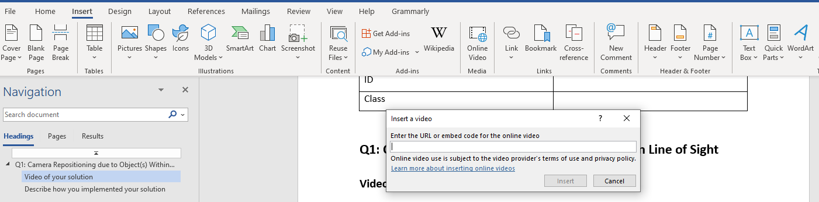

## Describe how you implemented your solution

*In this section, you will describe how you have implemented your solution. Take inspiration from the worksheet notes. Explain with diagrams if necessary.*

## Reflect this learning experience

*In this section, reflect on your learning experience associated with this activity.*

*What have you learnt? How can you use this learning experience? Did you find it challenging to implement?*

# Q2: Configure a new Character for the Player

## Video of your solution

*In this section, you will provide a video demonstration of your solution. Take inspiration from the worksheet videos that I have provided within the notes. To insert a video, first, upload the video to Youtube (you can keep it as unlisted or public). Then in Microsoft Word, go to Insert->Online Video and then provide the link as shown in the picture below. No commentary is required for the video. Just show your solution.*



## Describe how you implemented your solution

*In this section, you will describe how you have implemented your solution. Take inspiration from the worksheet notes. Explain with diagrams if necessary.*

## Reflect this learning experience

*In this section, reflect on your learning experience associated with this activity.*

*What have you learnt? How can you use this learning experience? Did you find it challenging to implement?*

# Q3: Implement Step Sounds

## Video of your solution

*In this section, you will provide a video demonstration of your solution. Take inspiration from the worksheet videos that I have provided within the notes. To insert a video, first, upload the video to Youtube (you can keep it as unlisted or public). Then in Microsoft Word, go to Insert->Online Video and then provide the link as shown in the picture below. No commentary required for the video. Just show your solution.*



## Describe how you implemented your solution

*In this section, you will describe how you have implemented your solution. Take inspiration from the worksheet notes. Explain with diagrams if necessary.*

## Reflect this learning experience

*In this section, reflect on your learning experience associated with this activity.*

*What have you learnt? How can you use this learning experience? Did you find it challenging to implement?*